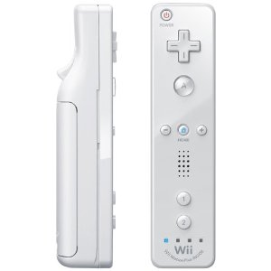TcVis Wii Remote Button Mappings

Decrease Sensitivity

Select

Increase Sensitivity

Switch Mode

Toggle Immersive Menu

Up/down/left/right

Release Up Vector

Attach/Release